**Personal Information:**

|  |  |
| --- | --- |
| **NAME OF THE FIRM** | KAMTECH ASSOCIATES PVT. LTD. |
| **PROPOSED POSITION** | TEAM MEMBER 2 (CAMPAIGN MANAGER) |
| **NAME OF EXPERT** | MR. MRIDUL KABRA |
| **NATIONALITY** | INDIAN |

**Educational Qualification:**

|  |  |  |  |
| --- | --- | --- | --- |
| **Degree(s)/Diploma(s) obtained** | **Time Period** | **Educational Institutions** | **Specialization** |
| B. Arch | 2011-2016 | Malaviya National Institute of Technology, Jaipur | Architecture |
| Senior Secondary | 2011 | CBSE | Science |

**Work Experience:**

|  |  |  |  |
| --- | --- | --- | --- |
| **Period** | **Employing organization and your title/position. Contact information for references** | **Country** | **Summary of activities performed relevant to the Assignment** |
| January 2019 - Present | Consultant at Kamtech Associates Pvt. Ltd. | Jaipur, Rajasthan India |  |
| December 2018- Present | BNI Global as BNI member | Jaipur, Rajasthan India |  |
| January 2018 - Present | Neta App as Director of Digital Marketing | Jalandhar, India |  |
| January 2018 - Present | Director VenturePact | Jalandhar, India |  |
| June 2015 - Present | Quadrigo as Digital Marketing Trainer/Teacher/Speaker | Rajasthan, India | * Taught more than 1000 college/school going students in a span of 1 year in Digital Marketing Training Workshops organised by UpNexTech in colleges and institutions all over Rajasthan. |
| March 2013 - December 2018 | Blogger, SEO and Google Adsense Publisher | Jaipur, India | * Started working in the field of Digital Marketing and Blogging after joining a Delhi based MLM where I learned the basics of making a website and generating revenue and sales from it. * Startedusing the Google Adsense ad publishing network to monetize over 50 blogs and websites of my own. |
| April 2017 - January 2018 | The NneHertz as Digital Marketing head | Jaipur, India | * Worked as the head the Digital Marketing activities at The NineHertz, for the company and its international clientele. Majority of the activities in Digital Marketing for the Company are focused on SEO, Social Media Marketing, Lead Generation and Pay Per Click Advertising. * Involved in:   + SEO   + Google Analytics   + Hiring own team |
| September 2016 - December 2017 | Tata Institute of Social Sciences as Head Faculty of Digital Marketing | Jaipur, Rajasthan, India | * Became the only student from MNIT to be a teacher at another college while still being a student, more importantly, because my bachelor's degree is in the field of architecture. |
| October 2013 - September 2016 | ArchitectBoy as Blogger, SEO, SMO | India | * Own blog which was able to gain 200,000 pageviews on a single day. |
| November 2012 - February 2016 | Androidweeds as Co-Owner | Jaipur, India | * Worked as the data analyst, SEO auditor and advisor for the website initially and later went on to play different roles including content creation and revenue   management through PayPal. |
| March 2013 - November 2014 | Web Development and SEO Trainer | Rajasthan, India | * Trained over 50+ associates about Web Development on CMS with a special focus on WordPress and Blogger. Also taught basics of SEO and SMO to the team of associates in Jaipur region for CIPL. Trained the associates working in   my team on how to train new recruits and associates |
| November 2013 - February 2014 | Jaipur Foto Festival as Digital Media Marketing Strategist and Head Event Co-Ordinator | Jaipur, India | * Worked as the event head at the biggest Photography event in Rajasthan (in 2013) and have been a part of the organisation since then. |

**Language Skills:**

|  |  |  |  |
| --- | --- | --- | --- |
| **Language** | **Reading** | **Speaking** | **Writing** |
| English | Excellent | Excellent | Excellent |
| Hindi | Excellent | Excellent | Excellent |

**Expert’s contact information:**

**E-mail:** kamtechmarketing@gmail.com

**Phone:** +917240000407

**Certification:**

I, the undersigned, certify that to the best of my knowledge and belief, this CV correctly describes me, my qualifications, and my experience. I understand that any wilful misstatement described herein may lead to my disqualification or dismissal, if engaged.

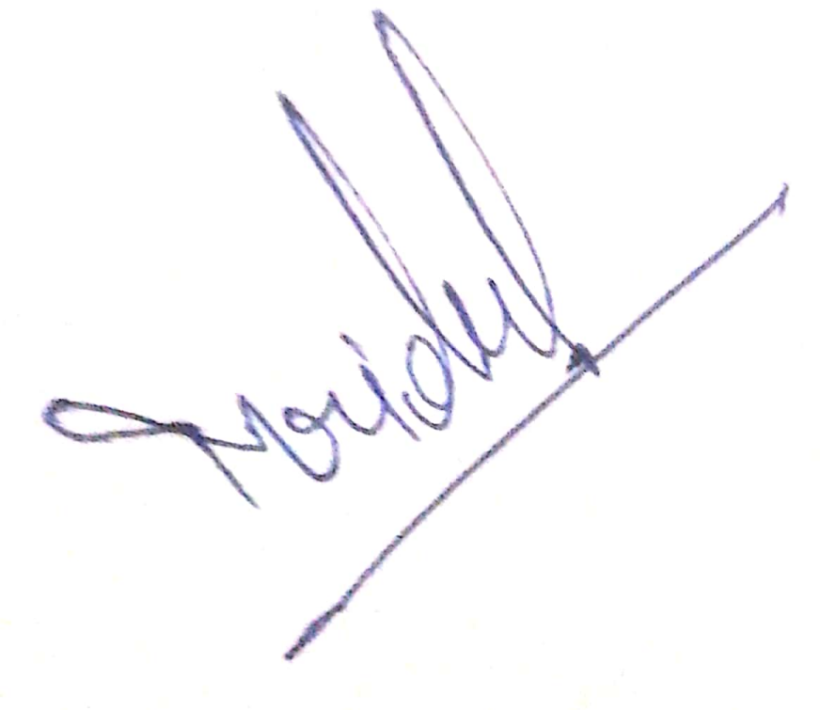

SIGN